

**The Arab American University**

**Faculty of Engineering and Information Technology**

**Computer System Engineering Department**

# **A Mobile Application for Improve Recycling**

**Senior Project 1**

Prepared by:

**Salha saaydeh 21511147**

**Sajeda Dnoof 21511055**

**Tala khuzaima 21511157**

Supervisor:

Prof. Dr. Mohammad Awad

Jenin 2019

**Acknowledgments**

We would like to extend our sincere thanks to our supervisor Prof. Dr. Mohammed Awad, who has been greatly credited for our support and assistance in completing this project, we thank the Faculty of Engineering and Information Technology for its Dean and its lecturers, and we do not forget our Families, who are sacrificing their most precious possessions for us, in order to become good engineers and able to assume the responsibilities and support our beloved country Palestine.

**Abstract**

Recycling is the process to change waste materials into new usable products. It is an alternative to “conventional " waste disposal that can save material. Recycling can prevent the waste of potentially useful materials, air pollution (from incineration), and water pollution (from landfilling). Preparing the environment for recycling is very important. Therefore, this process is carried out in the best possible way to collect waste that will be recycled. The recycling process includes recyclable materials for example glass, paper, cardboard, metal, plastic, tires, textiles, and electronics, so we need to put the waste disposal and separate these materials and identify them. No environmental culture or awareness about the problems that the wasted garbage causes to the environment, most likely the Palestinian people and municipalities don’t have awareness and ignore this problem also there is no laws punish offenders. New technologies can be applied to the recycling sector as intelligent containers, which are very expensive.

Our objective is to improve recycling rates by facilitating such work to citizens and even motivate their use. Launch a mobile application with which citizens can share their recycling practices. This mobile application to improve the results of the selective collection in the city or country. The objective is that users can use the mobile application to organize and to inform the recycling company about classified waste materials. They can report the malfunction of service or raise opinions and criticism of the solutions adopted to manage waste. This application locates, in addition, the nearest locations to collect the classified waste to decrease the collection cost by using smart clustering algorithm and the GPS with the connection with Google Map. The mobile application will contain a special section of courses and educational videos on the subject of sorting and recycling waste garbage. Also, the application will also contain a special section for the events of the application’s users. The application will contain a checkbox for the user’s questions and feedback. The application will support the subscriber locator system so that each user is added to the application database. There will be a contests section that will be held at the level of schools, universities, and restaurants. The application will allow users to display their electronic parts and spare parts available for sale. The details of each item, for example, a person who has a car engine, will be able to share a picture of it on his profile with details, quality, and price.

The developed and launched the Recycle concept, an integral system that encourages more efficient recycling, saving costs and generating profits. The mobile application system makes it possible to determine areas where awareness campaigns are needed to improve recycling rates and indicates which citizens can be rewarded for their proper separation of waste. For citizens, this system gives them more knowledge on the correct way to recycle, contemplate cities that are more sustainable and responsible with the Environment and, even, benefit from bonuses to apply in the municipal rates for recycling more and better.

An addition and future option is materials container and allows notifying directly to the recycling company as that the container is full, etc. It will also provide collection and recycling data for the municipalities that comprise it. The application is part of the recycling campaign, which aims to increase the awareness of the citizens in Palestine regarding recycling.

**Table of Contents**

**Acknowledgments …………………………………………………………………………..………..1**

**Abstract………………………………………….…………………………………………..………...2**

**List of figures…………………………………….……………………………………….…………..5**

**Chapter One: Introduction……..…………….………………………………………………..……6**

**1.1 Background and Motivation ………………...…………………………..……………..6**

**1.2 Aims and objectives……………….……………………………………..………………9**

**1.3 Problem Statement ……………….……………………………………..………………10**

**1.4 Contributions…………………….…………………………………….………………...11**

**1.5 Overview………………………….…………………………………….………………..12**

**Chapter Two: Literature Review...………………………………………...……………………….13**

**2.1 Overview……………………...……………………….....................................................13**

**2.2 Existing Systems …………...……………………………………………………………13**

**2.3 summary………………….……………………………………………………………...16**

**Chapter Tree: System Design…………..………………...……….………………………………...18**

**3.1 Introduction…………………………………………………………………………...…18**

**3.2 Hardware……………………………………………………………………………..….18**

**3.3 Architectural design …..…………………………………………………………….......18**

**3.4 System Design ……………………………………………………………………..…….19**

**3.5 Clustering algorithm and TSP algorithm………………………………………….......20**

**3.6 Payment Algorithm ……………………………………………...……………...….…...25**

**3.7 Use case diagram………………………………………………………………….……..26**

**3.8 Class diagram …………………………………………..…………………………..…...29**

**3.9 System Database (entity relationship diagram)…..…………………….………..……30**

**3.10 JavaScript for mobile application…………………………………….….…..….……34**

**Chapter Four: Conclusion and Future Work……………………………………….………….....35**

**4.1 conclusion…………………………………………………………………….……….....35**

**4.2 future works………………………………………………………………………..…....35**

**References ……………………………………….……………………………………….………......37**

**List of Figures**

**Fig 2.1 Zahrat Al-Finjan.……………………………………………………...14**

**Fig 2.2 Sample from E-waste recycling project.………………………..…..15**

**Fig 2.3 Smart Dust………………………………………………………………15**

**Fig 2.4 Smart bin.………………………………………………….………….16**

**Fig 3.1 System Architectural design ……….…………………….……….…..19**

**Fig 3.2 System Design ………………………………………..……………..…20**

**Fig 3.3 Clustering algorithm 0.1 ……..………………………………….…….21**

**Fig 3.4 k-means algorithm, a) …………………………………………………22**

**Fig 3.4 k-means algorithm, b) …………………………………………………22**

**Fig 3.4 k-means algorithm, c) …………………………………………………23**

**Fig 3.4 k-means algorithm, d) …………………………………………………23**

**Fig 3.5 clustering algorithm 0.2 ………………………………………………..24**

**Fig 3.6 TSP algorithm ……………………………………………………….…25**

**Fig 3.7 user payment algorithm …………………………………….………….26**

**Fig 3.8 Factory payment algorithm…………………………..………………...26**

**Fig 3.9 use case diagram ……………………………………………...………...28**

**Fig 3.10 Class diagram…….…………………………………………………….29**

**Fig 3.11 Database (entity diagram)……..……..…………………….………….30**

**Fig 3.12 different OS using JavaScript……..…….…………………….………34**

**Chapter one**

**Introduction**

**1.1 Background and Motivation**

Our planet is dying because of the pollution that wasted garbage made. Nowadays, humans do lots of actions that harm the environment. this reflected badly on the living creatures , lots of races have been extinct, the climate changed rapidly and has gone topsy-turvy(Global Warming), holes in ozone layers, spread of new diseases , the Ice in the North Pole and the South melted, that’s led to a rise in sea level, air pollution, The rate of natural disasters has increased dramatically in recent times. Plastic waste is littering our oceans and threatening the lives of millions of marine animals. Seals, whales, dolphins, seabirds, fish, crabs and many other sea animals are dying and becoming sick because of this deadly environmental concern. All this would not have happened if it was discovered early.

Recycling from common methods of waste treatment and management, which collects and processes waste materials with the help of families, to convert them into reusable products. This process has many advantages. It eliminates the step of sending waste to landfills or incinerators, protecting the air from contamination by fires or emissions. As well as protecting the environment from the consumption of new raw materials, meaning that they provide the consumption of natural resources such as wood, water, and minerals, on the other hand, the recycling of waste contributes to energy consumption, and is a means to increase employment in the country followed, without losing sight of economic interest; as easy to benefit from a local source of resources thereby increasing the economics of the country.

There are benefits for Recycling: economical, socially, environmentally. From the economical view, it will Increase the income of the country in general, Individuals in particular and reduce the costs of healthcare resulting from pollution. The social view will improve the quality of life, reduce transmitted diseases and increase public awareness of the preservation of the environment. From the environmental view, it will Conserve biodiversity, reduce the risk of pollution. In Palestine we have a large experience in recycling, it is a big project called Zahrat Al-Finjan but it was and still a big failure. The project was designed and built to serve Jenin and Tubas with a capacity of 300 tons per day to serve the northern governorates of the West Bank in addition to Ramallah and Al-Bireh and the Palestinian communities, which reduced the life of the project and increase the difficulty of dealing with the amount of waste. The amount of waste buried in the project reaches 3 million tons currently. The project is in his final stage. The addition of new small cells to the area of ZahratAl-Finjan will serve only two additional years in the first phase of the project.

In addition to other problems related to the project, such as quantities of juice that are difficult to treat and odors and the rejection of the local community of the presence of the landfill in the area and the permanent claim to close or limit the landfill only to the provinces of Jenin and Tubas. It should be noted that the Council made previous attempts with the private sector to solve the problem, but it has failed because of the lack of economic feasibility and the lack of factories to re-manufacture recyclable materials and not absorbing the idea of ​​separating the garbage from the source of it. The amount of waste entering the landfill from the governorate of Jenin at a daily rate of approximately 290 tons and The quantity of waste from the city of Jenin at the rate of 80 tons per day. The waste collection during the year 2018 from the governorate of Jenin 104455 tons. Here are the percentages of every category per one ton:

1. Percentage of organic matter 53.5%.
2. Paper and cardboard ratio of 14%.
3. The plastic ratio of 11%.
4. Glass ratio of 1.5%.
5. The ratio of minerals 3%.
6. Other materials 17 %

Imagine if we recycle half of this amount, the problems will decrease to 80%. And imagine this is just from one governorate, Look at this great residence of the other governorates.

Tables 1: Statistical Information about the waste amount in Palestine.

|  |  |
| --- | --- |
| **Name of LGU** | **Actual waste collected (T/year)2018** |
| Jenin | 104455 |
| Tulkarm | 57387 |
| Nablus | 92940 |
| Tubas | 14083 |
| Ramallah | 78735 |
| Qalqilya | 36132 |

During the contact with a number of the heads of the municipal councils in the region, did not appear to be concerned about the work of the landfill, especially that the board of services for the joint consists of the heads of municipal and village council in the region.

Some of them see that the subject is no more than a culture, which considers the subject of waste is inferiority and sensitivity, especially that one health problem was not recorded as a result of the landfill. But our Investigations say the opposite. This was confirmed by the technical director of the landfill Engineer Mohammed Al-Saadi, adding that if there were health problems on the citizens and the ocean was the first to be infected is workers of the site and the number of them is about 200 workers dealing directly with the treatment of all types of waste that reach the landfill. Here we will comet that workers have special equipment to deals with these risks. Some of the protestors went to accuse the landfill of receiving Israeli waste or settlement waste.

When we asked Saadi, he answered that those who deal with the landfill are trustworthy in the sense of municipalities, municipal councils, and villages, and when their trucks are received, this is based on the trust between the administration and the sender of those wastes.

"Yes, there are buses with Israeli registration plates coming to the site, but we cannot distinguish if they are settlement waste or other, but we receive waste from our known destinations," he said.

It is worth mentioning that the project was established in the Zahrat al-Fanjan area (Wad Ali) between Ouja and Arraba, 17 km south of Jenin, 25 km west of Tubas, 24 km north of Nablus, 24 km east of Tulkarm, 50 km north of Qalqilya. The project received financial support with a value of $ 14 million, which $ 9 million was from the World Bank, $ 1.2 million from local authorities, $ 3.75 million from the European Union, with a capacity of 2.25 million tons of waste. [1]

Over the past few years, smartphones have emerged in various types and forms. Smartphone applications have emerged and have played a big role in the lives of smartphone users, especially young people, which is the largest segment in the use of smartphone applications. It has become a successful and effective way for entrepreneurs to promote their products and institutions in a modern way. Help them reach as many customers as possible in a short time.

With smartphones, applications are taking most of the time that users have on their phones, and high web browsing rates from smartphone applications make companies and even non-technical projects seriously think about creating apps. This covers a large market of operating systems.

The Arab world also has statistics from the pewglobal.org center. The percentage of smartphone users in the Middle East is 95 % of the total population, 57 % of whom have smartphones and 36% have non-smartphones.

In contrast, GSM - Global System for Mobile - estimated the number of mobile subscribers in the Middle East and North Africa at 635 million people, or 63% of the population. The percentage of subscribers to smartphone services in occupied Palestine reached 76% or 3.78 million subscribers. [2]

Our project is based on the JavaScript for mobile application because there is no one that does not own a phone or smart device. Mobile applications take less money, everyone will get it because there is no money need for an application. If it returns in a financial and educational benefit, all individual will install and use it. Also, all kind of Operating Systems will be compatible with the mobile application. It will be easy to use, we will achieve usability for all different ages.

**1.2 Aims and objectives**

Our intelligent mobile application aims to achieve many goals. To give all aspects benefits and save our world. The stated objective is as follows:

* To represent and promote the recycling industry for the benefit of all individual in society.
* To raise personal and public awareness of environmental issues, including the benefit of reducing, reusing and recycling of materials that would otherwise be sent to landfill sites.
* To be a principal voice for the recycling industry.
* To represent the interests of members at local, national and Palestinian government level with direct contact and through our application.
* To develop best practice in the recycling industry by promoting:

1. Health & Safety standards.
2. Legal and Regulatory compliance.
3. Operational standards.

* To provide a source of information for Members on matters relating to the waste and recycling industry, including:

1. Health & Safety.
2. Industry benchmarking.
3. Technical developments.
4. Training & education.

* To organize networking and social fellowship events in order to improve communication between individual and traders and factory owners.
* To increase the number of members involved in recycling.
* To provide an effective voice and focal point for community recycling in Palestine.
* To work towards a shared zero waste future.
* To increase education relating to REDUCE, REUSE, RECYCLE.
* To minimize environmental impact and pollution.

**1.3 Problem Statement**

The problem of waste has become a global problem, and therefore all countries are trying to control these things through the work of large waste dumps (areas). These dumps are far from homes and far from residential areas. The second phase of garbage collection consists of waste sorting. This is done by sorting out waste and trying to get some recyclable things, such as plastic and some other things that can be recycled and used. They are then recycled in special factories, and new products are acquired, without the feeling that they are duplicates. This was one way in order to reduce the amount of output in our surrounding environment pollution.

The accumulation of waste in different forms in the environment leads to the leakage of their contents from toxins to different sources of water, whether groundwater or surface, which negatively affects the vegetation cover and the life of different living organisms and humans, in addition to the emission of odors very unpleasant and disturbing, and distort the landscape and aesthetic values of nature As a result of their accumulation. We have that in Zahrat Al-Finjan, Ajja and other cities 14

Around Zahrat Al-Finjan have already demonstrations because of the odors and emission that caused diseases and harm to the citizen, lots of Ajja’s citizen have moved to other cities.

In our society, there is no culture of recycling and sorting the wasted garbage into categories. it is a daily site to see the citizen throw garbage everywhere from the cars, the roads, the homes, schools, restaurants, health centers, hospitals and lots more. Without even thinking about the disadvantages of those actions. Also, we have a sarcastic attitude of whom talking about saving earth and recycling and throwing garbage. But we will treat these attitudes and beliefs and the fossilized mentality with money. How is that?

The second problem that we have is that the municipalities neglect and disrespectful of this subject. They are not prepared to make a Financial and physical effort to solve the problem of garbage accumulation. Like we saw in the comments of the interview about Zahrat Al-Finjan, Supervisors said that “the subject is no more than a culture, which considers the subject of waste is inferiority and sensitivity “. So in our project, we will not contact with government agencies.

The third problem is money, this kind of projects needs lots of money like Zahrat Al-Finjan it cost $27.95 million but our project will just need 3 sides the factories, traders and craftsmen and the subscriber and our project which includes our application and a car for each city, a car for Jenin, Nablus and so on .

**1.4 Contributions**

We have proposed a mobile phone application to solve these problems, so anyone can easily install this application, and we will solve all these problems mentioned above, firstly we solve the problem of lack of land area that used for garbage collection. How is that? We transfer the sorted waste from the subscriber to the contractors immediately and inefficient way, so we don't need a place to put the waste.

Increasing awareness and culture among citizens about the importance of waste recycling and non-accumulating waste in their surroundings by encouraging them to collect and sort waste in an indirect way for a sum of money for each quantity they collect. When we collect the rated garbage from the subscribers, we will send it for factories, traders and craftsmen that we contracted with them previously. The beginning will be to solve this problem ourselves, without having to go to government agencies or contract with the municipalities, at the lowest possible cost. How is that?

the car will work on intelligent algorithms to reach every subscriber (restaurants, houses, wedding halls, schools ….) in a short distance and in a suitable time using clustering algorithm and neural network, all of this is already exist and does not cost that much money.

**1.5 Overview**

We will provide a literature review and all project and ideas closest to the project in chapter 2. Then in chapter 3 will present system design (software). Finally, in the last chapter, some conclusions and any further work will be submitted in the near future.

**Chapter Two**

**Literature Review**

**2.1 Overview**

In this chapter, we will talk about existing systems that are partially similar to our system. However, there are many systems that aim to help a particular category of people which is a blind category. Furthermore, these systems aimed to make a special function or mainly one function, our mobile application will include several functions to be taken into consideration. It is worth to be mention that some of these systems do not take its place to operate, but it is categorized as theoretical researchers.

**2.2 Existing Systems**

There are many existed recycling systems, different in size, functions, costs, and equipment used in. To view these systems, we select some systems with different characteristics.

**2.2.1 Waste Recycling Company in Palestine (PADICO)**

The Palestinian company (PADICO) for waste recycling in 2010 is the first company specialized in Palestine to provide environmental solutions in the field of solid waste. The company started implementing its first project in the city of Nablus, which includes the separation of waste from the province, such as plastic, cardboard, and metals, and sorting out the organic materials that will be converted to organic fertilizer (humus).

The project aims to provide suitable solutions for municipalities and common services councils for the disposal of household and commercial waste in a sound and environmentally friendly way by sorting the components of waste collected by municipalities and local councils. It is worth noting that all the civil works of the project and the installation of all production lines have been completed by the end of 2012 and that the company will start its operations in 2013, and the total investment in the project is about the US $ 3 million. In 2010, the company purchased a 25% stake in the major waste recycling company executed in the city of Jenin. The project was launched in Jenin in September 2011.

The company was to treat 75% of the waste in the Nablus governorate. The company's production will be mainly for hummus, which is a basic material in the agriculture process, which will benefit the farmer on the one hand and contribute to the reduction of the cost. The process of transporting and dumping waste to municipalities and councils, as well as maintaining the environment clean and safe. The plant will operate with a capacity of 200 tons per day, which is the amount of waste from the city of Nablus and the surrounding communities. [3]

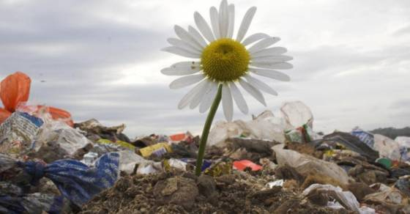

Fig 2.1 Zahrat Al-Finjan**.**

**2.2.2 E-waste recycling project in Burundi/Anatolia**

Computers, televisions, old refrigerators, and other electronic devices that have exceeded human needs, accumulate in the corners of the Burundian cities and gradually erode causing many environmental damages because they contain toxic substances such as lead and mercury. Here it uses an application to collect this material to recycle it. [4]

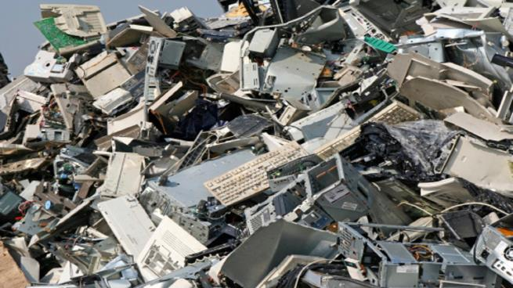

Fig 2.2 Sample from E-waste recycling project.

**2.2.3 Application for waste recycling in Beirut (Lima)**

The application connects homeowners to local garbage collectors to regulate waste collection from homes. The application will make it easier for people to recycle many kinds of waste, whether glass, plastic, iron, mix, or paper. The application will allow collectors to earn more money when collecting more waste from the houses and will record all of this through the system points on the application. Recycling companies can also offer rewards to homeowners depending on the quantity and quality of waste they separate and submit to collectors. [5]

**2.2.4 Smart Dust**

There is also a smart garbage bin, a bin that raises the lid when someone approaches to throw the trash inside and closes the lid when the process is finished. [6]

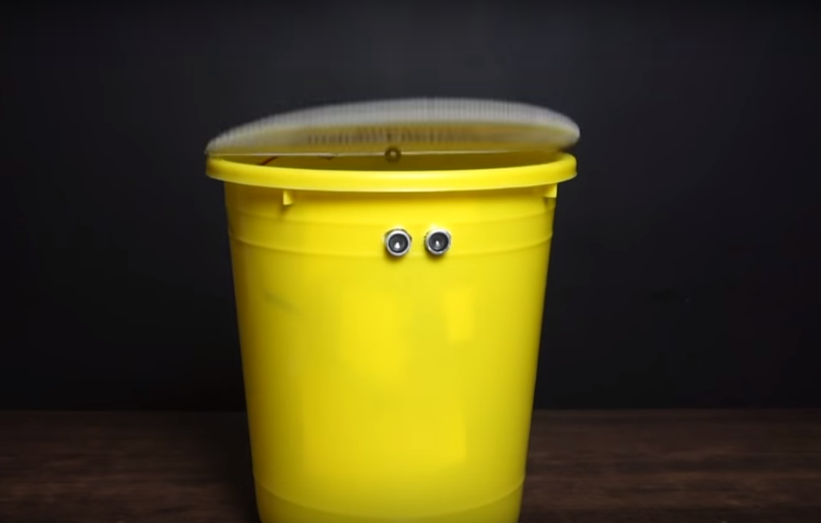

Fig 2.3 Smart Dust.

## **2.2.5 Smart Bin**

In this project, a smart bin was manufactured to separates the plastic and aluminum can. [7]

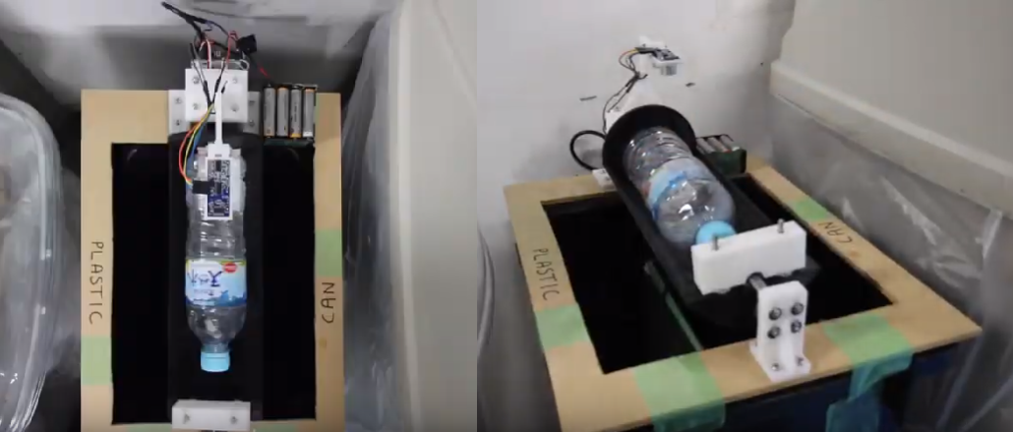

Fig 2.4 Smart bin.

**2.3 Summary**

The previous systems are based on collecting the garbage from the Waste dumps and then separate it. Also depends on who deals with garbage, not the whole community, that will not affect the culture (will not change it). These systems are not intelligent it doesn’t use AI or any new Algorithms, use the old way. These systems will not be applicable in our country cause we don't have respect for State property, it will be ruined these public properties. And these systems need a big budget and money.

Our system will collect the garbage from its sources which are already separated. It will affect the culture because there is revenue and this will change the community culture. Our project will be used by all the community members not just the workers. Our project will use intelligent algorithms and architecture to improve the waste collecting in a way that the money is more and time is less. We will use the AI in our project. We will not communicate the governmental agencies so there will not be a public property used. Also, our project will not need a lot of money, because we are using an application and used cars. It is good to mention that our system will contain features that will make our system to a more reliable, the mobile application will able to use neural network and clustering algorithms to predict the amount of waste from each subscriber and the percentage of each time in the amount. It will be able to recycle everything in our lives, anything you want to disposal. It will start to educate people and encourage them to sort waste in exchange for an amount of money. It will transfer the garbage directly which provides a solution to the problem of waste accumulation in landfills and exploitation in a correct and environmentally friendly manner. Our project will be comprehensive for all materials of cardboard, glass, metal, food, etc. Our project will be more efficient, more functional and more financial.

**Chapter Three**

**System Design**

**3.1 Introduction**

In this chapter, we will view the software and hardware components that we will use in our system. Moreover, we are going to discuss the algorithms and the flowcharts that our system will follow to implement its functions.

**3.2 Hardware**

In our project, we will need a transport mechanism that will collect the separated waste so we will need an intelligent car that can store the separated garbage in an easy way. This will need a lot of money, but we will use other smart solutions like using existing unused cars that the government had, it the time that they don’t use these cars.

**3.3 Architectural Design**

The reason why we use the MVC architecture because we have logical that represented in physical components that interact with each other, also these components manages the data of the system that are stored in the cloud (database), and the operations on these data.

The view component here is the user interface in the application which presents the data to the user. The Controller component is the application which manages the user interaction passes these interactions to the cloud and the user interface and the bank for the money transactions, vice versa, as shown in fig 3.1.

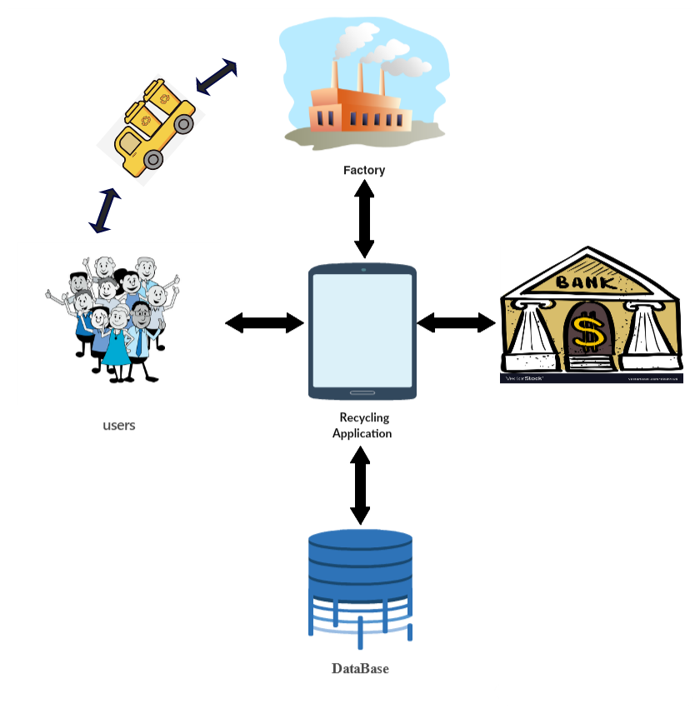

Fig 3.1: System Architectural design

**3.4 System Design**

The main goal of this system is to provide a better environment to live in. to save our planet and save all living creatures by collecting and delivering the separated waste from and to the clients, and because we have financial benefits that will change the culture of people. since our system is an intelligent and will do some kind of intelligent collecting to save money and make the collected tour more feasible, we should develop an algorithm “ flowchart “ explaining how the system should work and how it should be programmed. First of all, we have the main algorithm which will contain several parts: request receiving, clustering algorithm, payment algorithm as shown in fig 3.2.

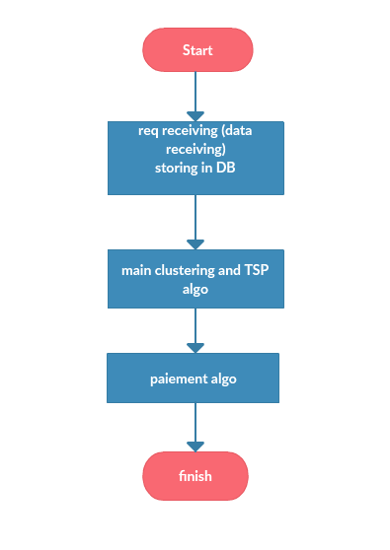

**Fig** 3.2: System Design

**3.5 Clustering Algorithm and TSP Algorithm**

Clustering is an attractive and smart technique for controlling the users’ distribution over wireless networks, yielding to a better distribution of clients to the available wireless nodes. We will use the clustering algorithm to divide the customers into clusters that will be processed separately for each cluster. This clustering algorithm contains Data extraction then will take the extract data to be processed at the Data processing stage. Then the processed data will be clustered by using the k-means algorithm. Then the data will be feed to the system, as shown in fig 3.3. [8]

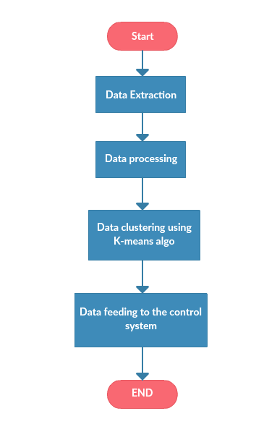

Fig 3.3 Clustering algorithm 0.1

***K-Means Clustering Algorithm pseudocode:***

* *K-Means Clustering*

1. Choose the number of clusters (K) and obtain the data points

2. Place the centroids c_1, c_2 ,..... c_k randomly

3. Repeat steps 4 and 5 until convergence or until the end of a fixed number of iterations

4. for each data point x_i:

- find the nearest centroid (c_1, c_2 .. c_k)

- assign the point to that cluster

5. For each cluster j = 1..k

- New centroid = mean of all points assigned to that cluster

6. End

As shown in the following figures 3.4, here is how the k-means algorithm work on a row data to separate it into clusters depending on the gathering of the point it will create the clusters then append the data to the closer cluster area.

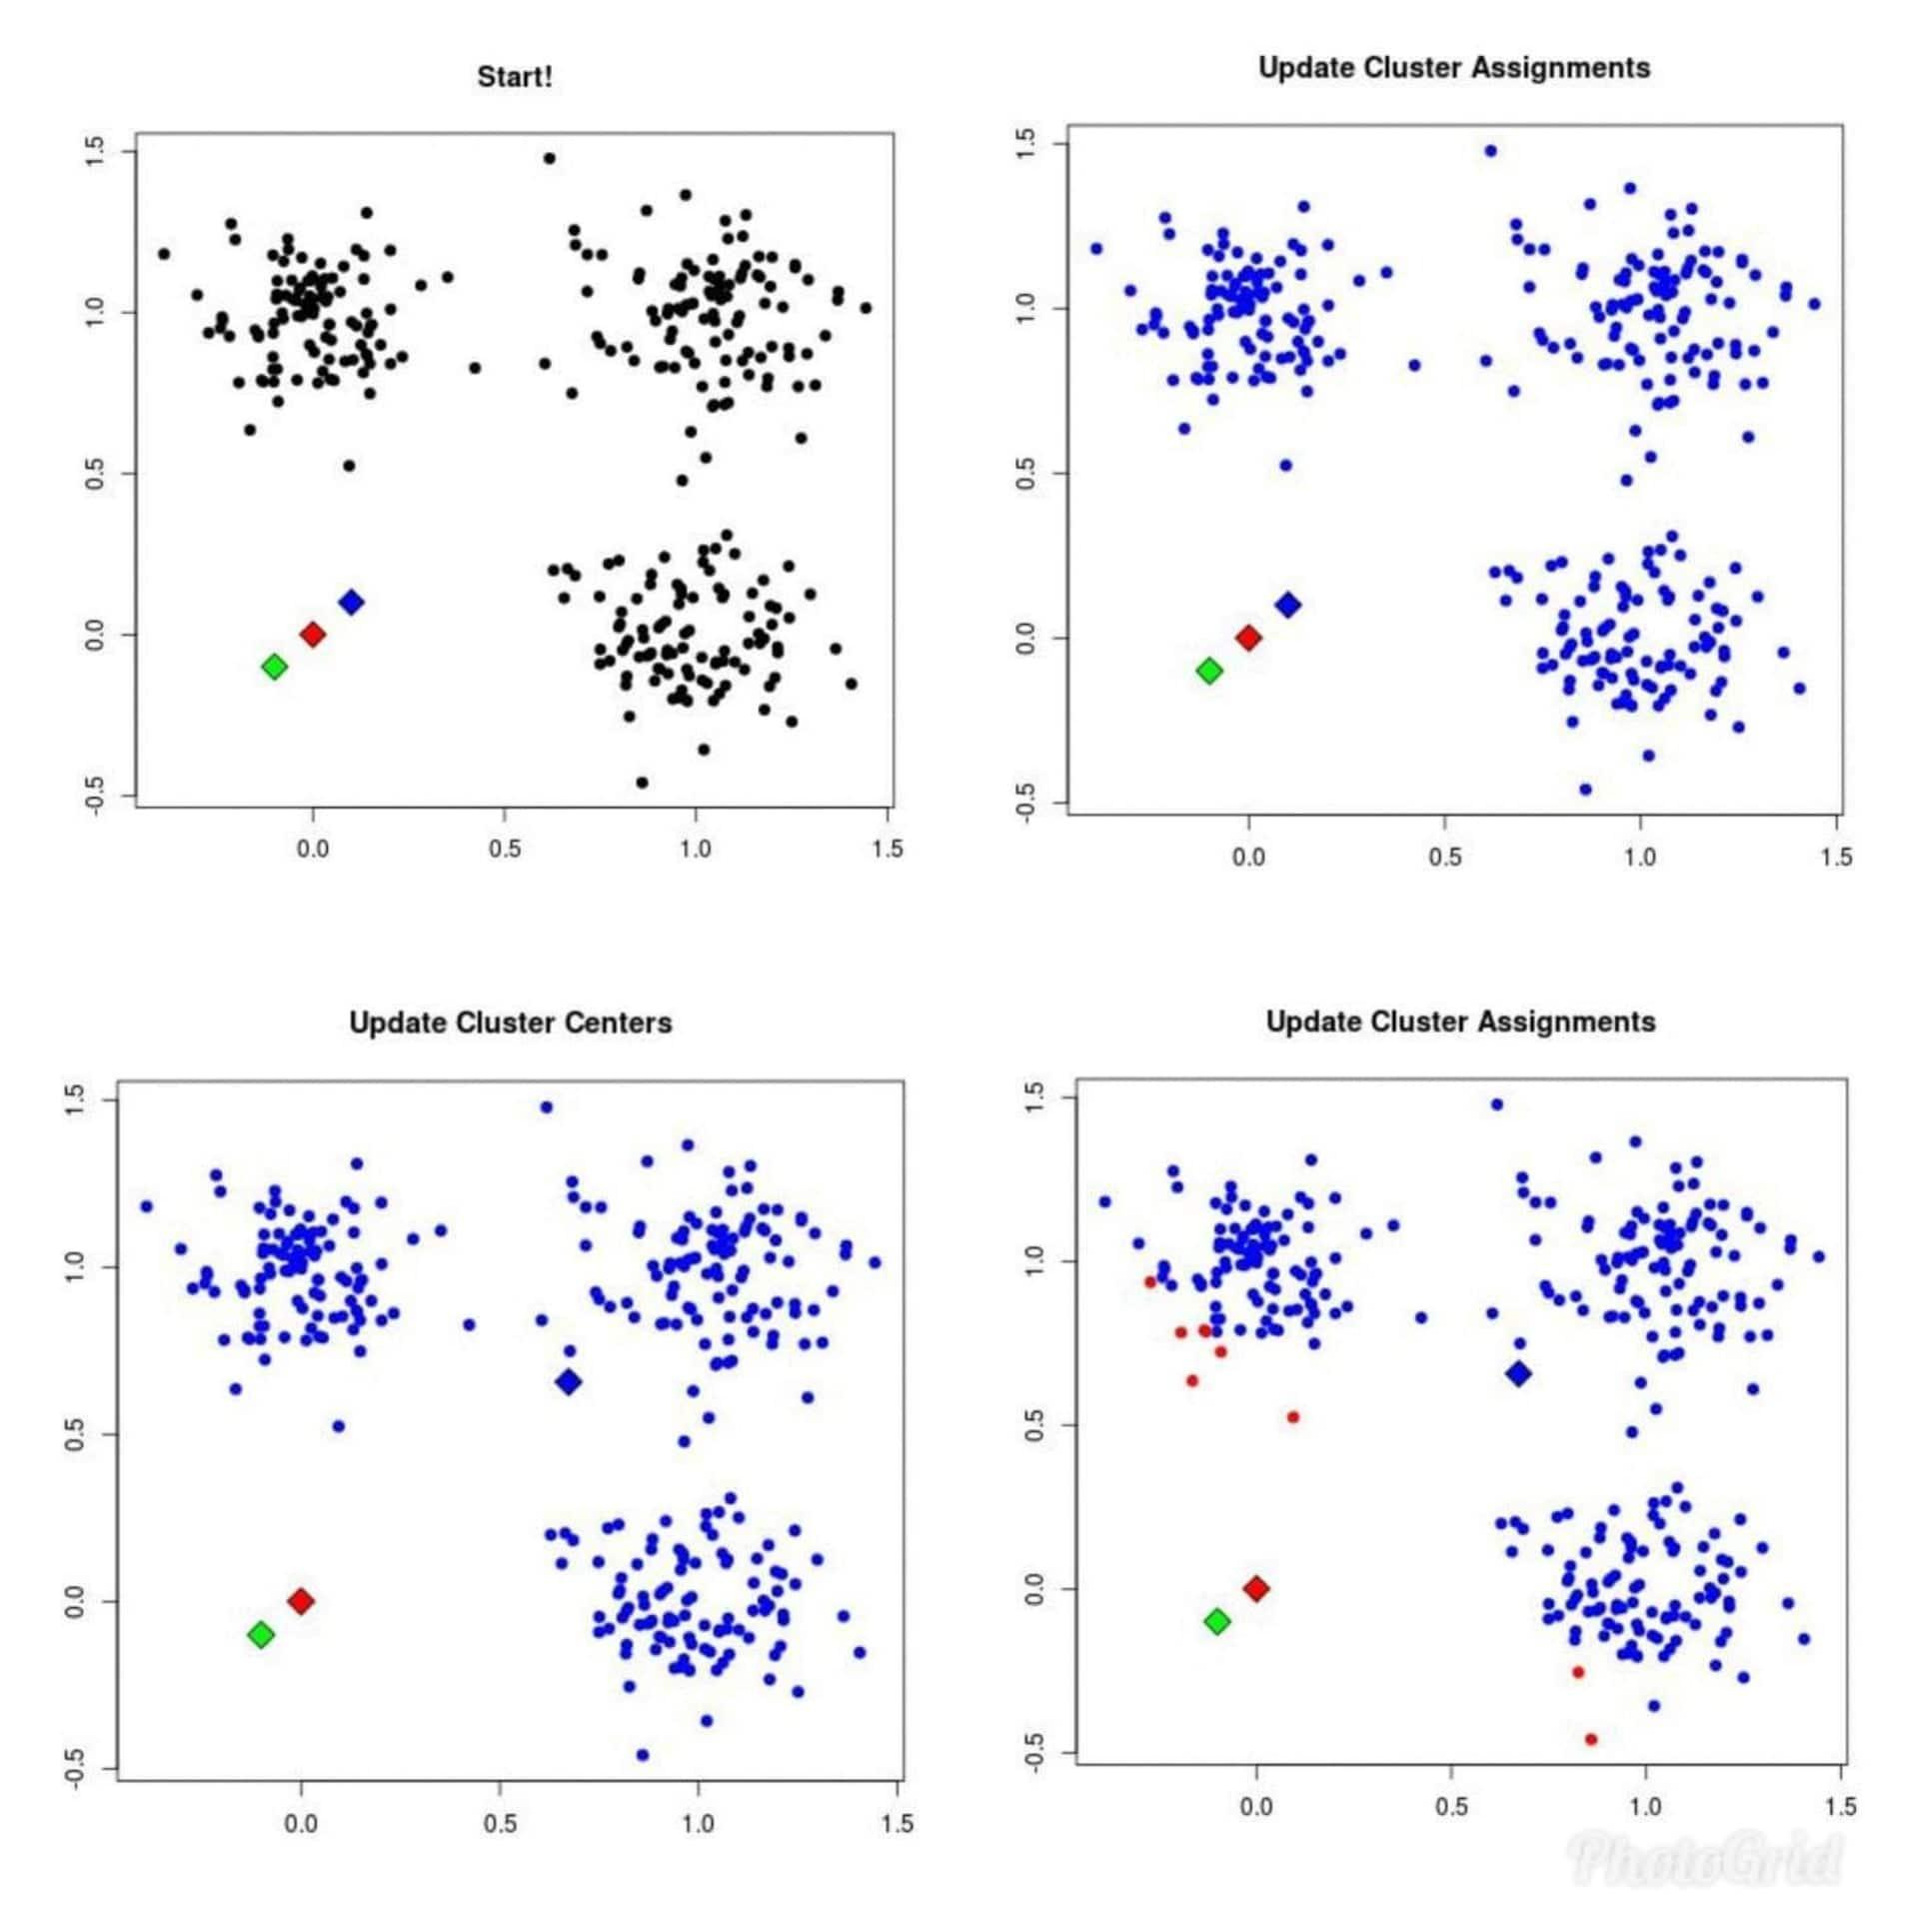

Fig 3.4 k-means algorithm, a)

Here in the first picture we have a three points red, blue and green. These colors represent the three cluster that will contain the requests, then the algorithm will take one of the cluster and put all the request in its area, then the algorithm will take the red point and append the closer requests to it.

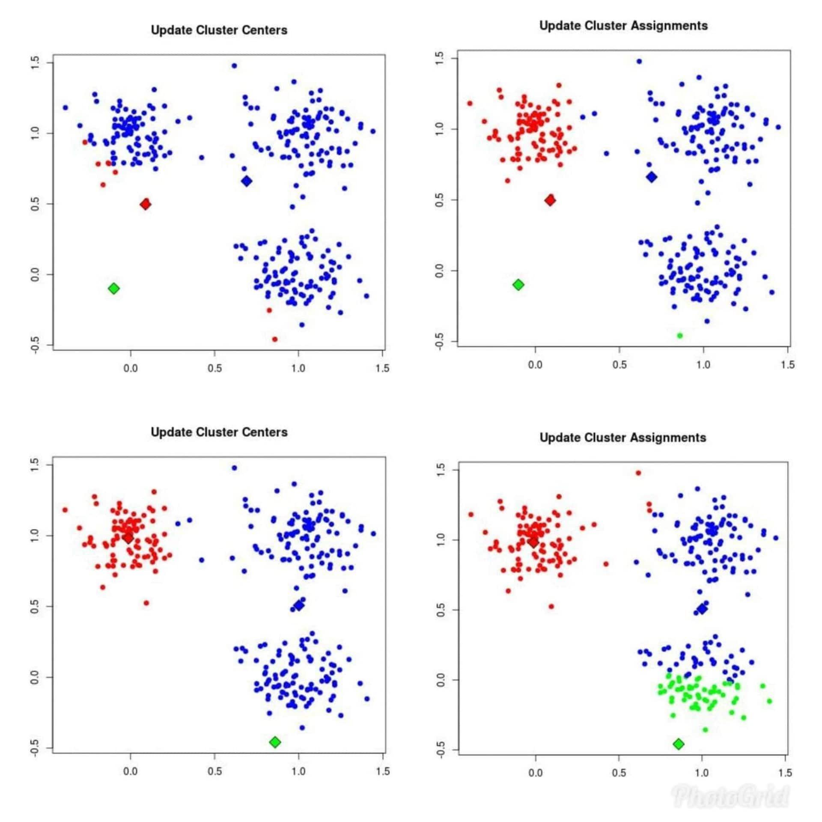

Fig 3.4 k-means algorithm, b)

Then the red point will change it origin to fit all the points that are close to it, the same algorithm goes for the green point (cluster).

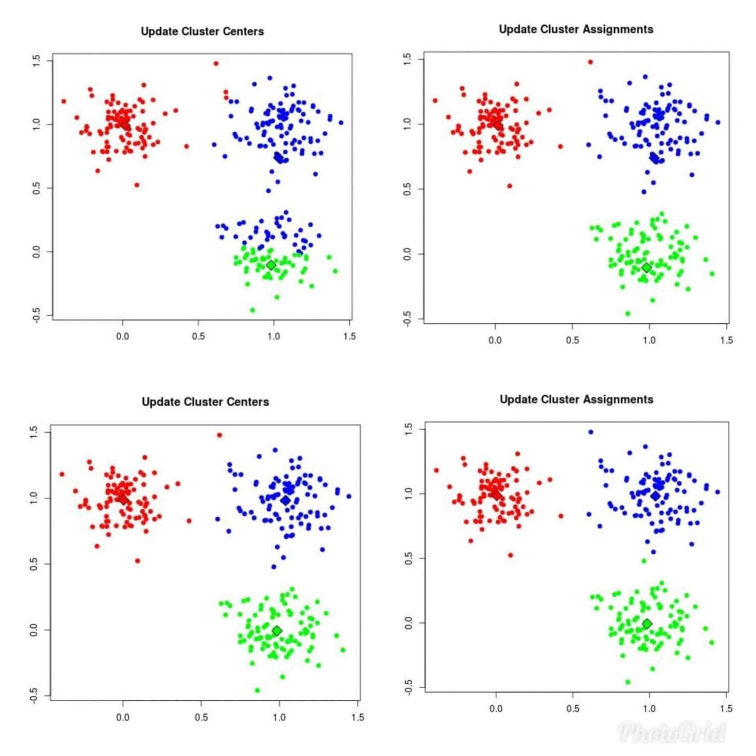

Fig 3.4 k-means algorithm, c)

Then the algorithm will start to change the clusters origins to fit the maximum number of points in the cluster, so each cluster will contain the closets points (requests) to it.

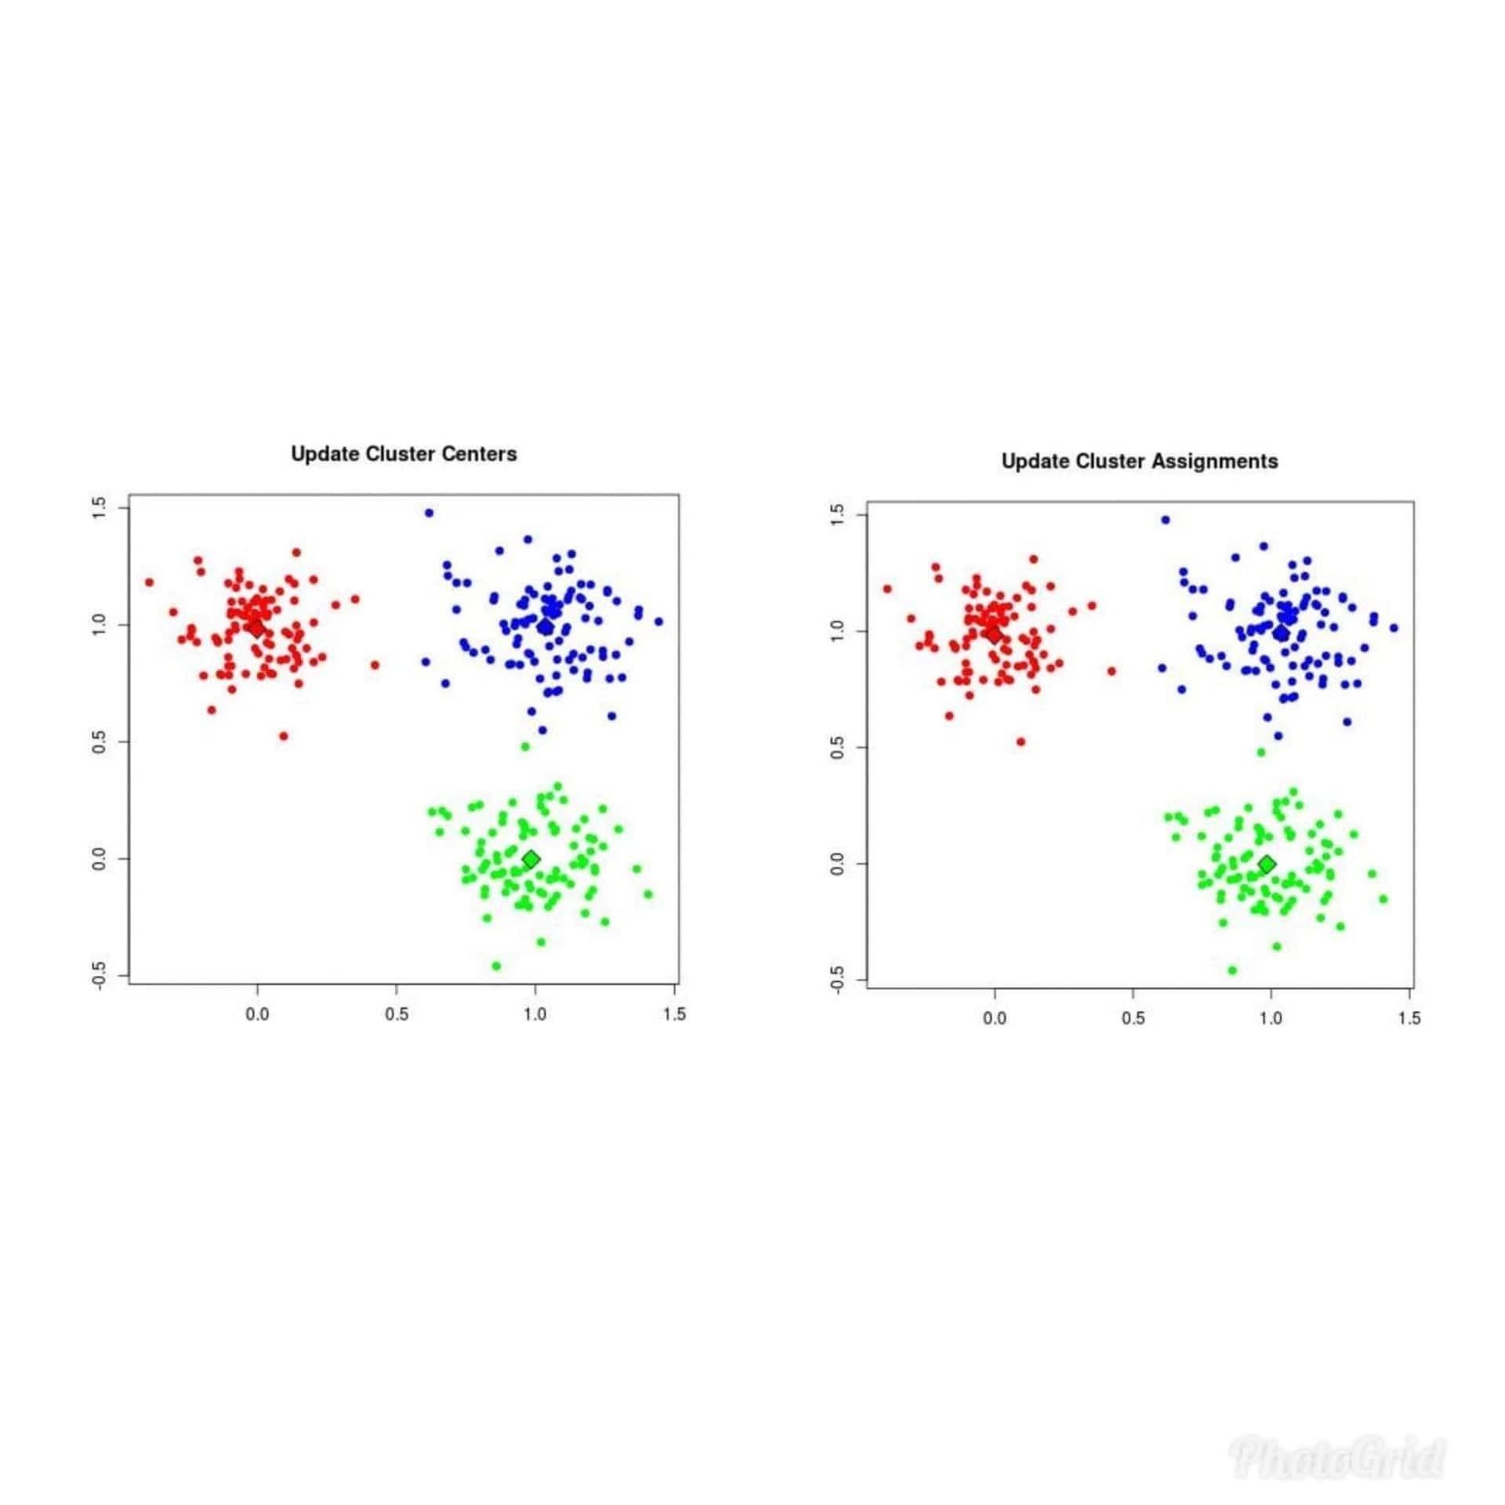

Fig 3.4 k-means algorithm, d)

Finally after fitting all the origin, the clusters are ready to apply the TSP algorithm on each cluster. After feeding the data to the system we will set the initial values depending on the municipalities in Jenin city. Then we will assign each request to the nearest cluster, then we will use the TSP algorithm for each cluster to determine the path in each cluster and take into consideration the feasibility of the path. Then for each new request, we will do back the algorithm, as shown in fig 3.5.

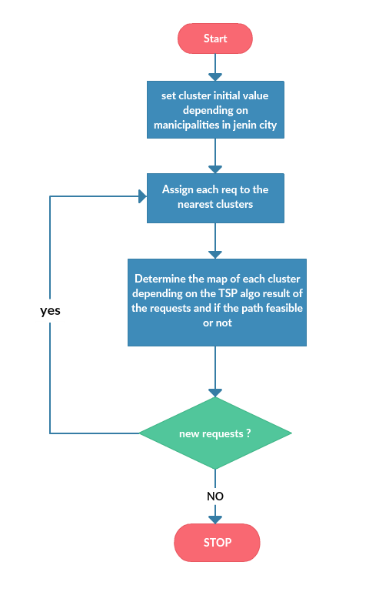

Fig 3.5 clustering algorithm 0.2

The TSP algorithm will produce the shortest path with minimum cost and time to make the path feasible, as shown in fig 3.6.

**Travelling Salesman Problem (TSP):** Given a set of cities or point on a map and distance between every pair of cities, the problem is to find the shortest possible route that visits every city exactly once and returns to the starting point. We will select the edge depending on the car location that will collect the waste. Then we will find all possible paths and calculate the minimum path cost.

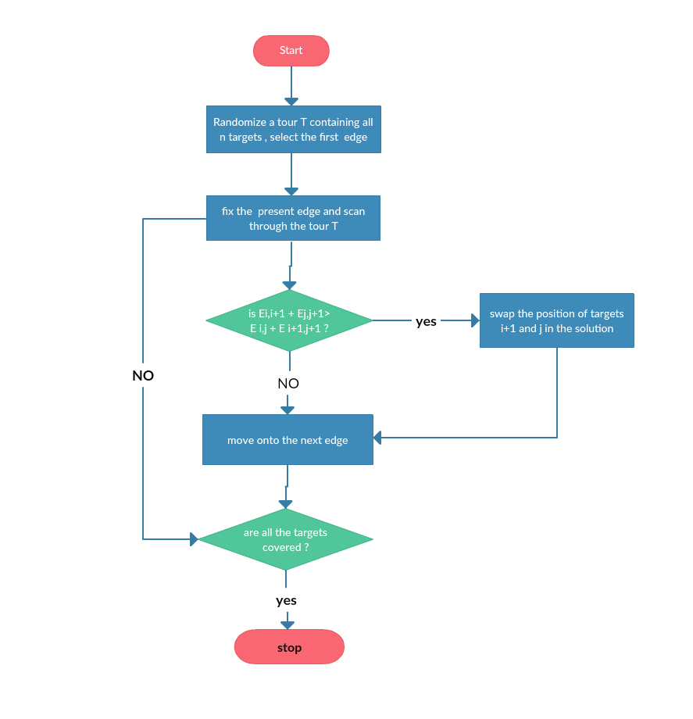

Fig 3.6 TSP algorithm

**3.6 Payment Algorithm**

Here the payment algorithm will organize the money transaction when the customers get the minimum value of points it will automatically send the appropriate quantity of money to the customer as shown in fig 3.7.

Then will withdraw the money from the manufacturer when the waste is delivered to the factory, as shown in fig 3.8.

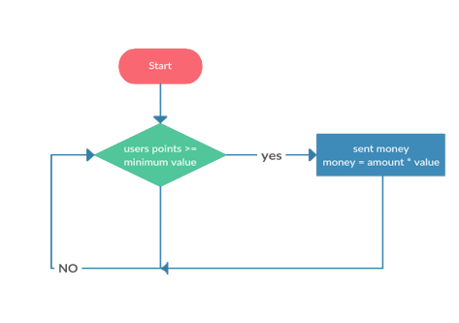

Fig 3.7 user payment algorithm

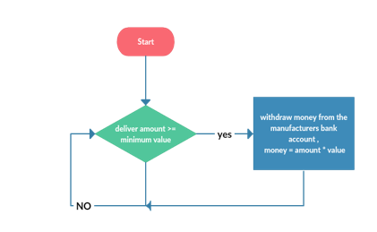

Fig 3.8 Factory payment algorithm

**3.7 Use case diagram**

Here are the use cases for each part which using the system, as shown in fig 3.9.

For the user, any user can register out application then login to the application. Also can logout from the app. Also the user can request and when the driver collect the waste from the user, the user will get a confirmation massage, also if the user use the manual way of reception the money, also when the driver give the user money, we will send a conformation massage. Also the user can report anything that hurt or offensive him by our services (feedback). Also the user can modify the personal information. The user can withdraw his payment from the system if he choose the bank account way of reception the money.

For the factory (plant), any plant can register out application then login to the application. Also can logout from the app. the driver deliver the waste that collected from the user, the plant will get a confirmation massage, and then the system will withdraw the money from the plant bank account. Also the plant can report anything that hurt or offensive him by our services (feedback). Also the plant can modify the personal information.

For the driver, any driver can login to the application. Also can logout from the app. Also the driver can modify the personal information. The driver will collect the waste from the user using the schedule that belong to him, the system will go and send a confirmation text during the collection cycle, also when using the manual payment for the user. The driver will deliver the waste to the factory using schedule that belong to him, the system will go and send a confirmation text during the delivering cycle. When the driver faces an abusive user, the driver can block the user by reporting this user and what have he done. The driver can withdraw his payment from the system.

For the project team, any project team can login to the application. Also can logout from the app. Also the project team can modify the personal information. The project team can withdraw his payment from the system. The project team can add user and block user depend on the reports from the driver.

For the system, the system can withdraw the money from the plant bank account. Also it will do an acceptance when the user register then verify when the user login. The system will do the financial transactions. And give each one his payment.

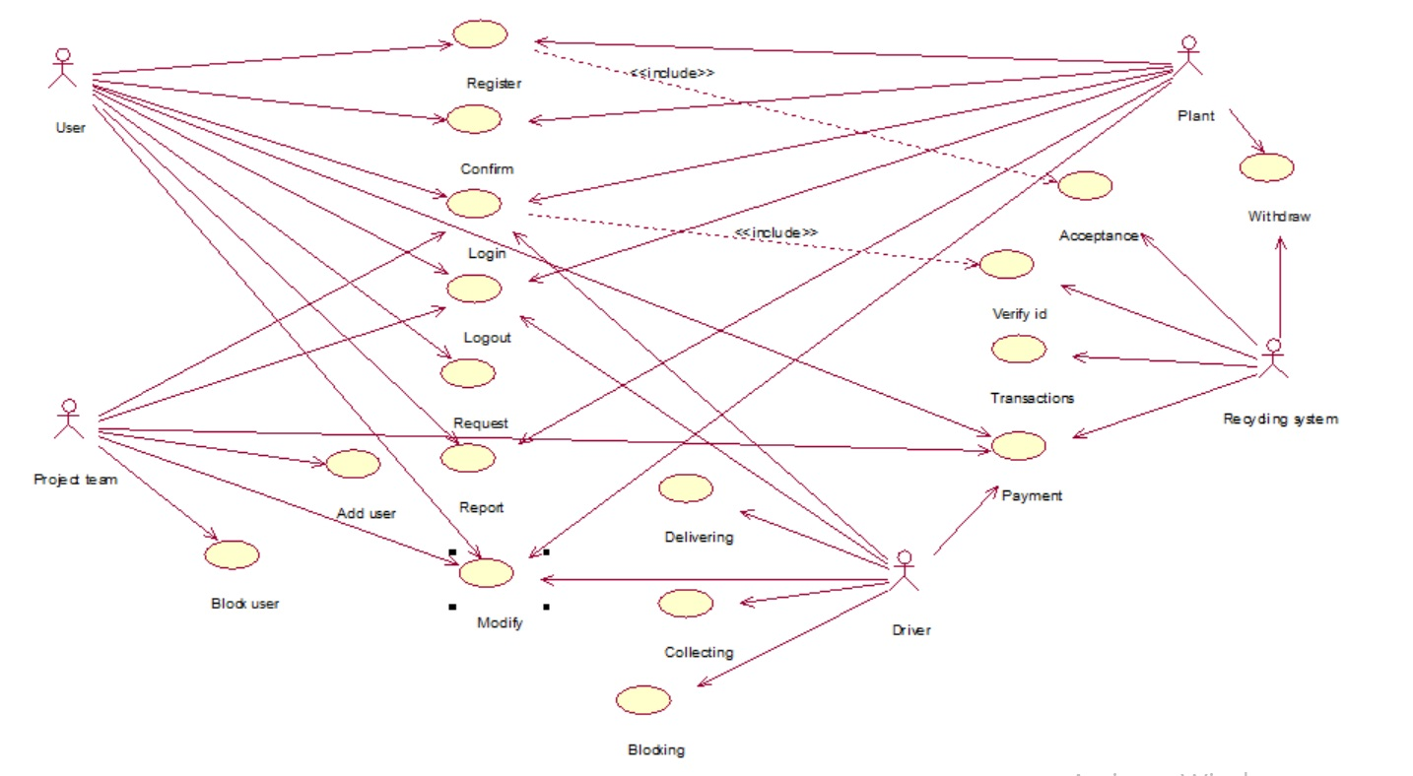

Fig 3.9 use case diagram

**3.8 Class diagram**

Here are the classes for each part of the system, as shown in fig 3.10. Here we have the objects in our system we use the inheritance to make the code dynamic, so it can be easily changeable. we have 4 kind of application users, which are the clients and workers. The clients are the customers and factories. The workers are the driver and the project team. Also we have customer kinds like wedding halls and a lot. Each of them have a special parameter to use it in the expectation feature (see in chapter four). The waste will have all the kinds that can be recycled, it differs from country to another. Also the car will contain all the available cars and the time. We have a system bank account to do the financial transactions.

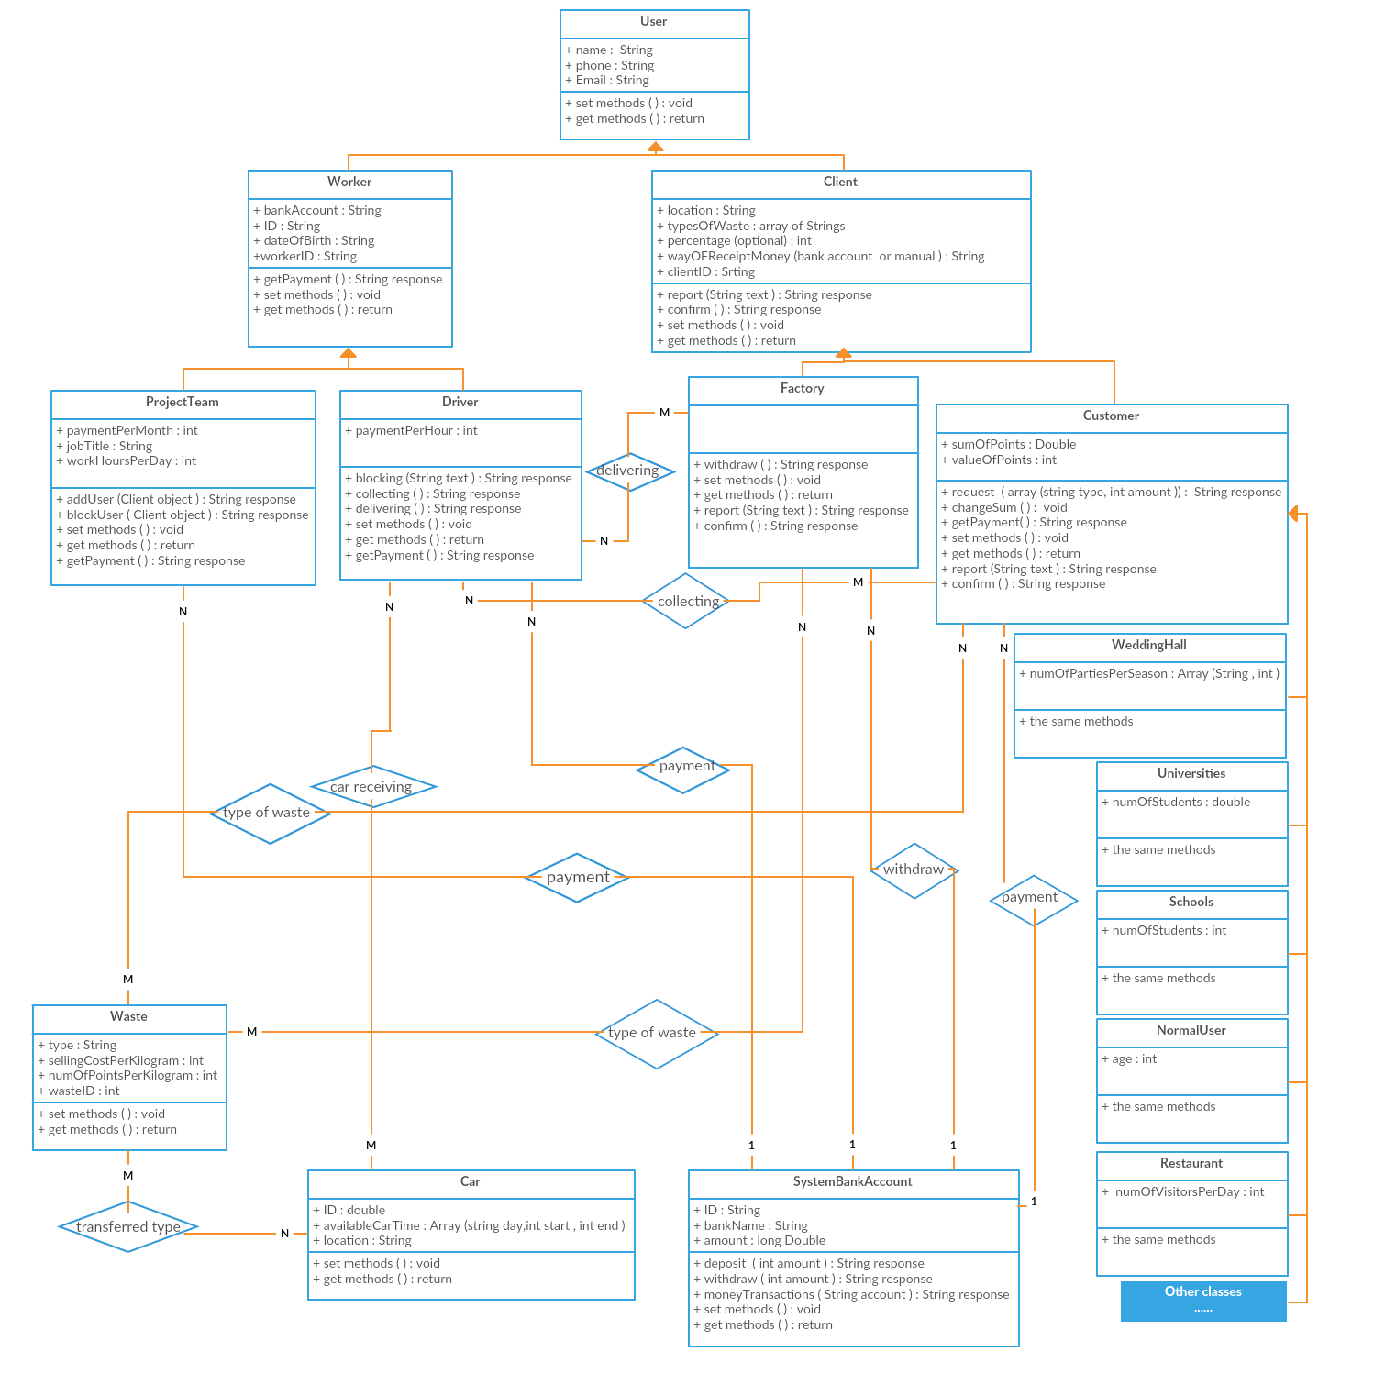

Fig 3.10 Class diagram

**3.10 System Database (entity diagram)**

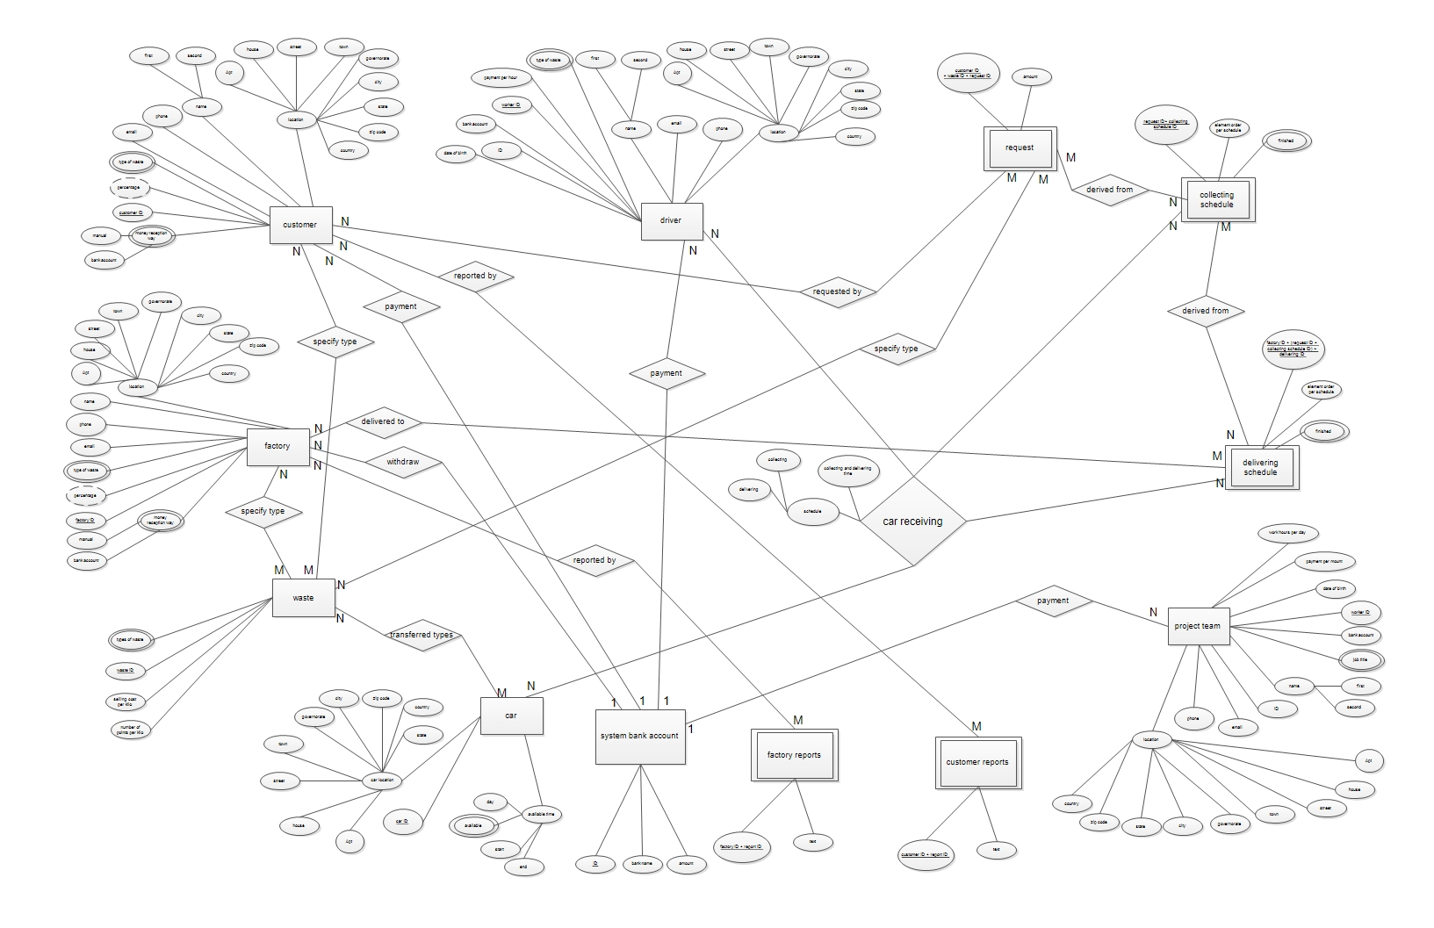

Fig 3.11 ER diagram.

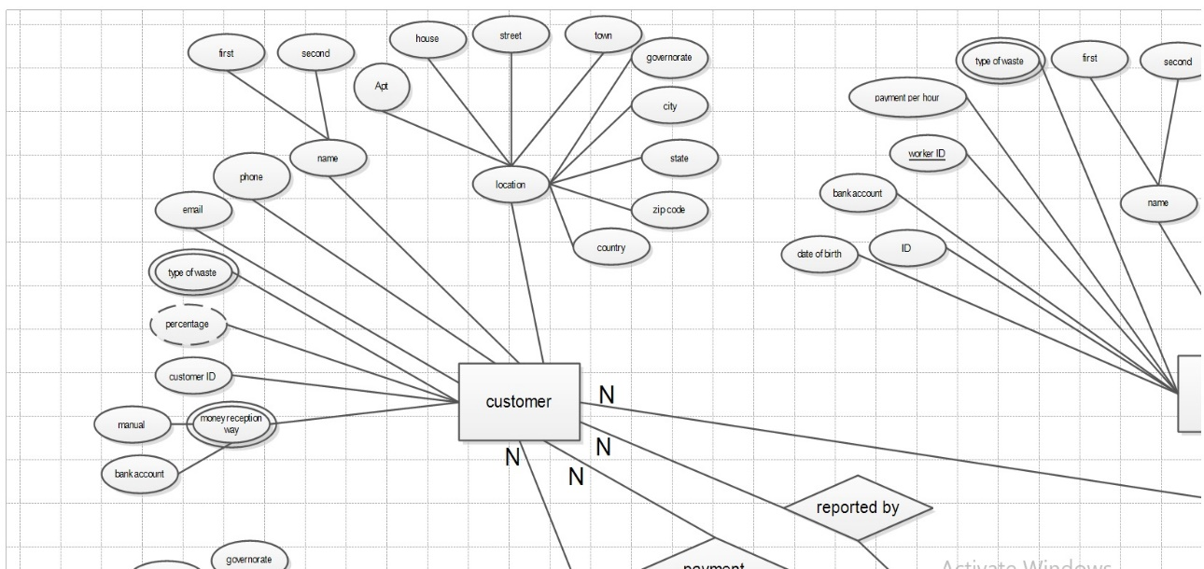

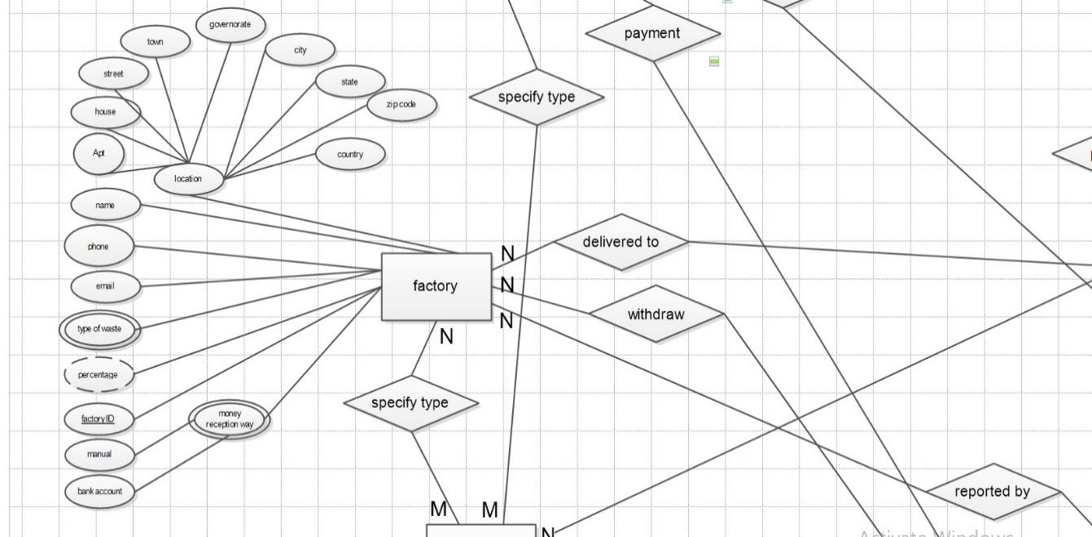

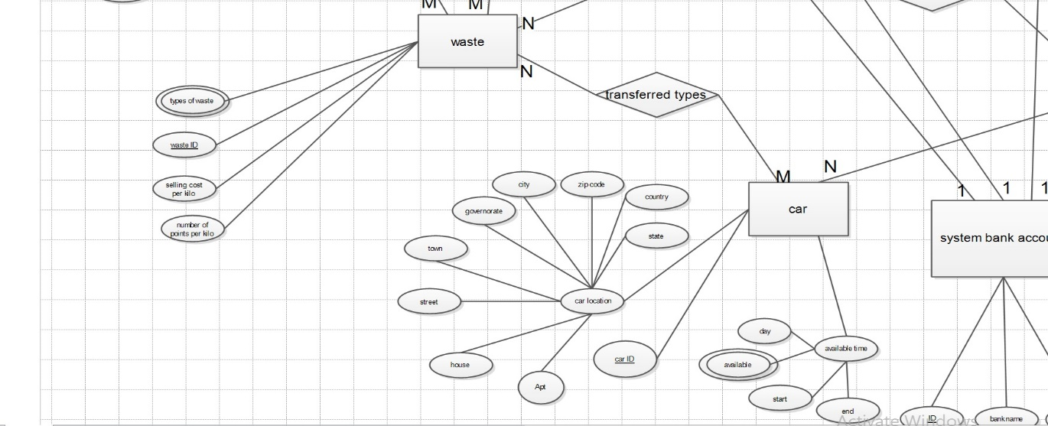

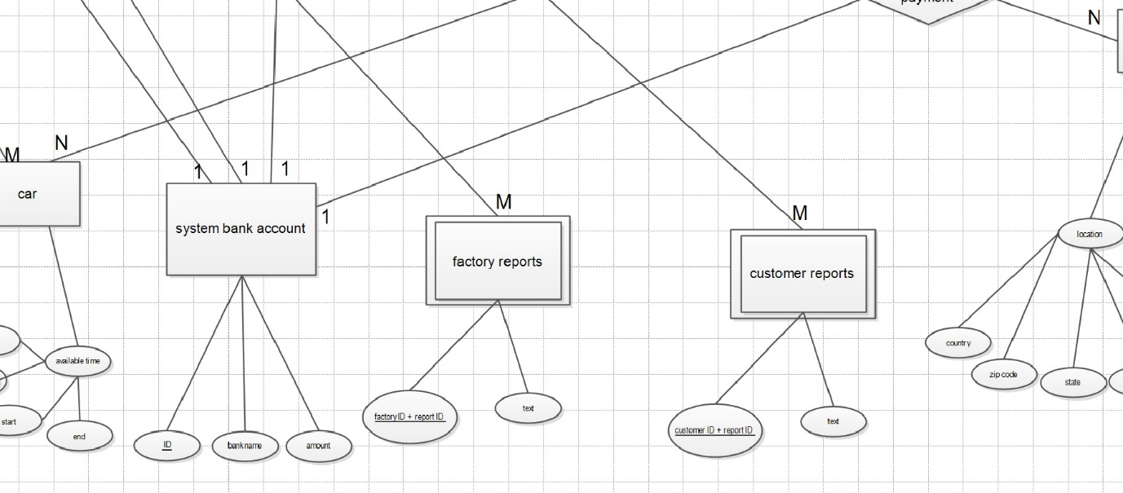

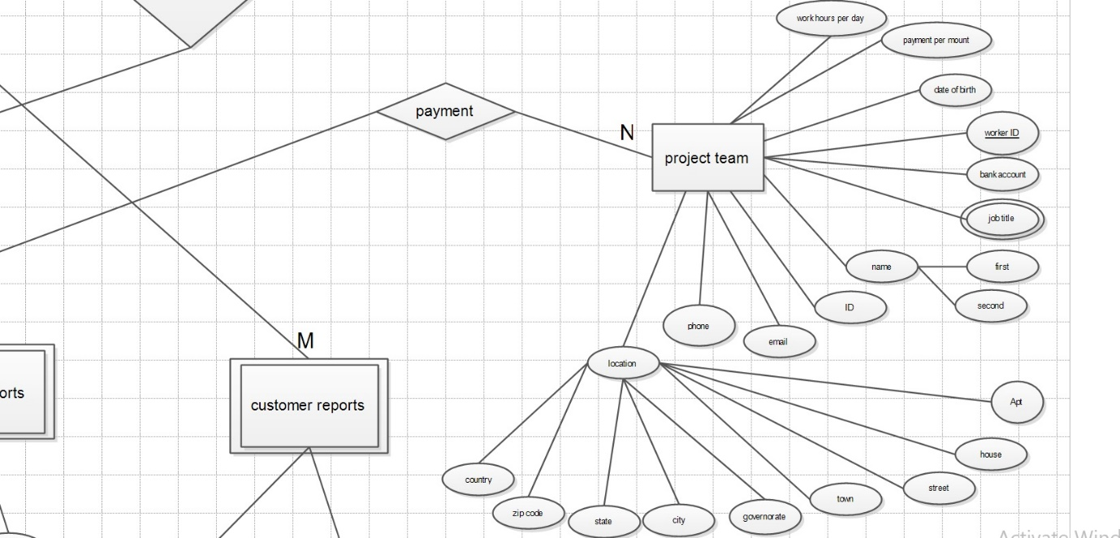

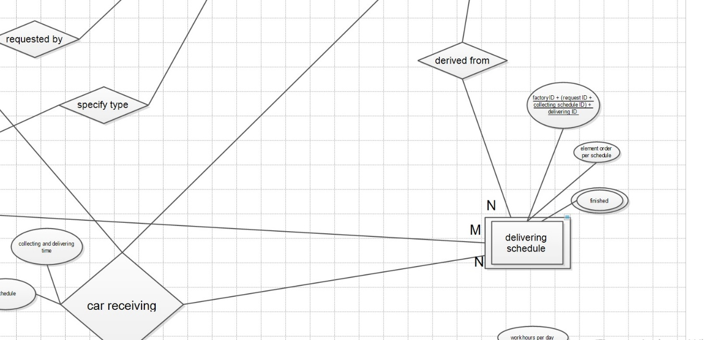

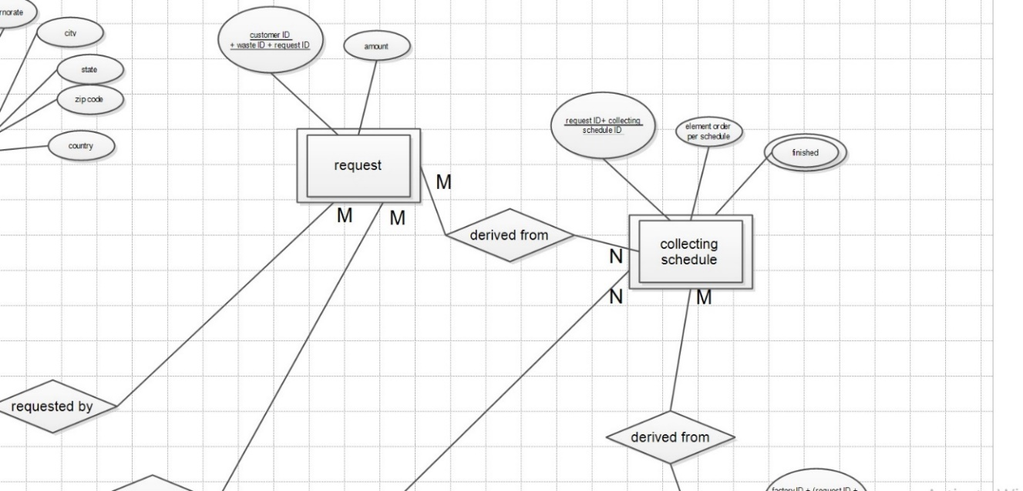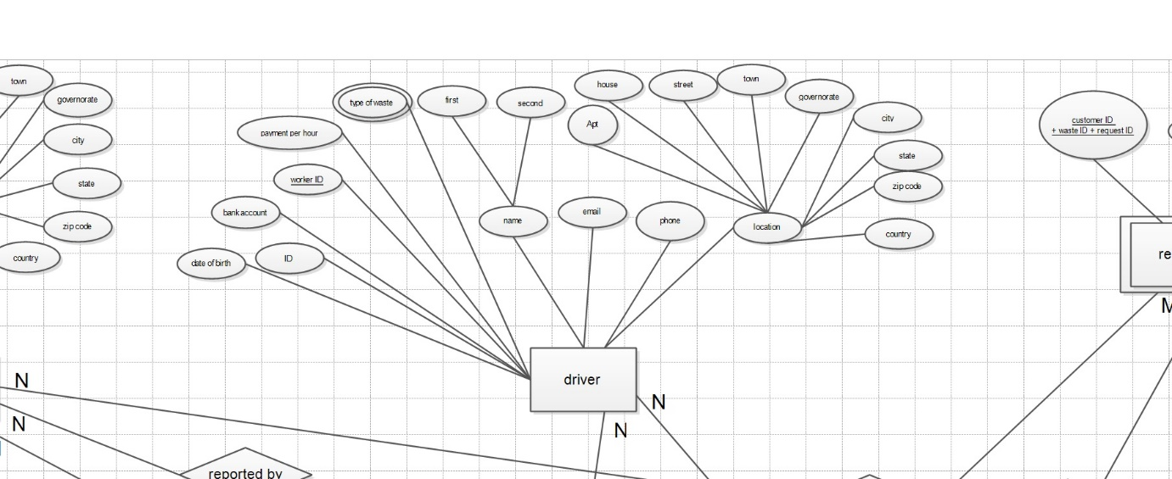

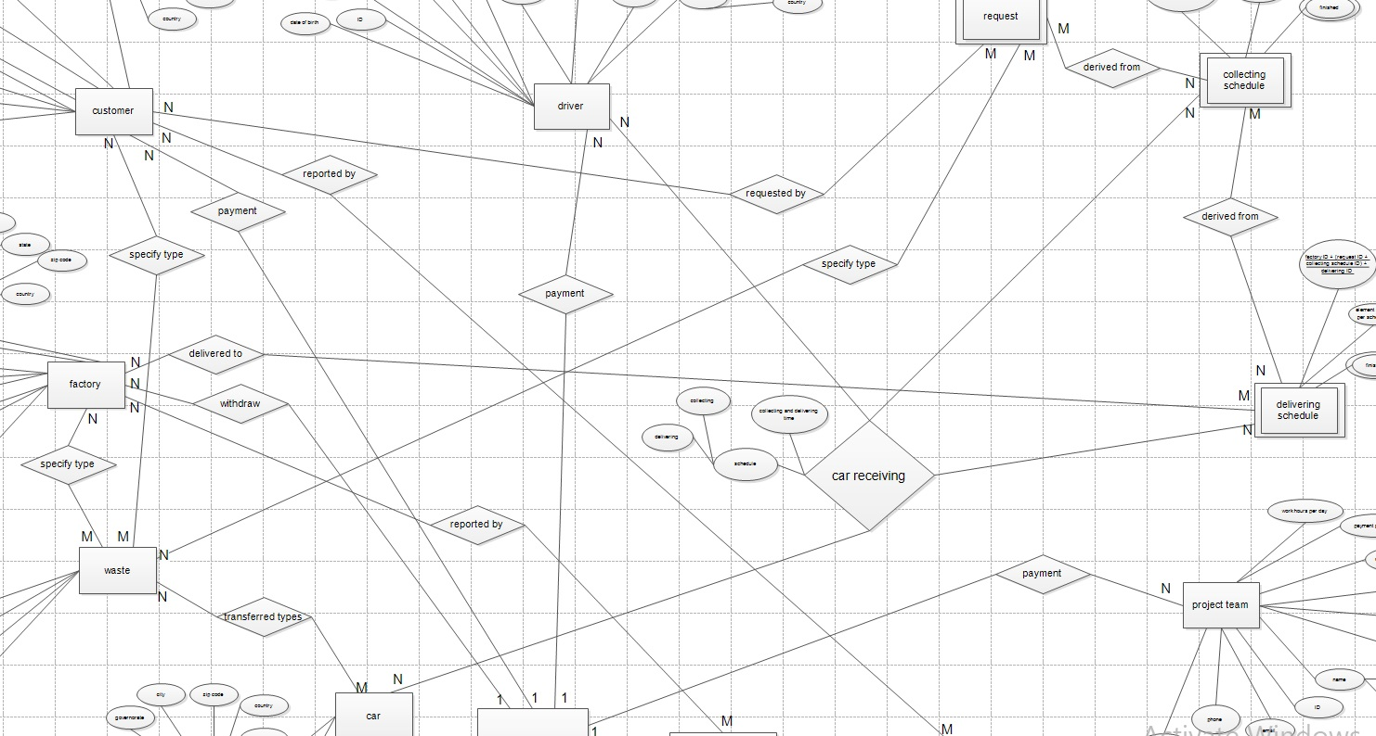

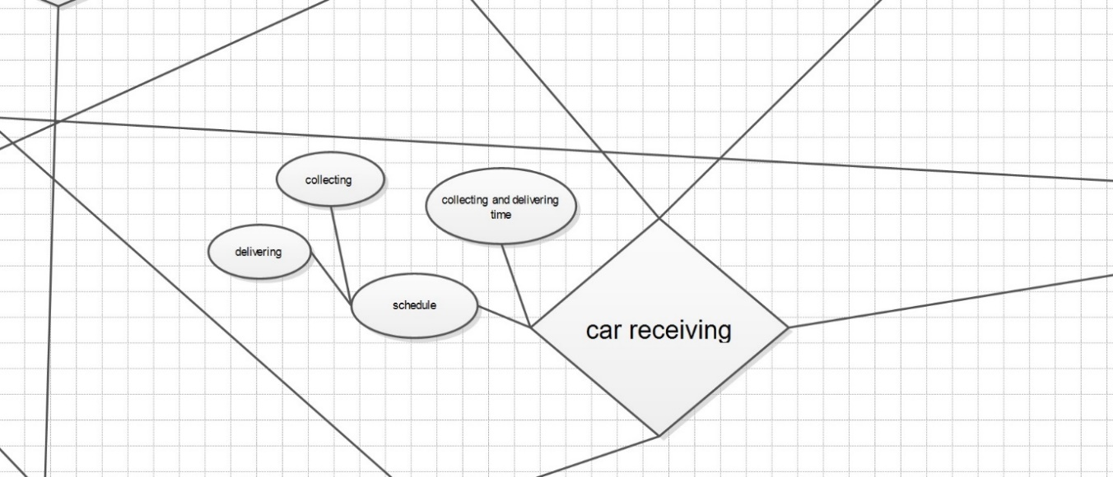

**3.10 JavaScript Programming Language for a mobile application**

Technically speaking, mobile apps in iOS, Android, and Windows Phone are coded using different programming languages.  An iOS app uses Objective-C, an Android app is coded with Java, while a Windows Phone application uses .NET. However, with a decent knowledge in JavaScript, CSS and HTML, you can build awesome mobile apps. It use a cross platform to represent the code to be applicate on different OS.

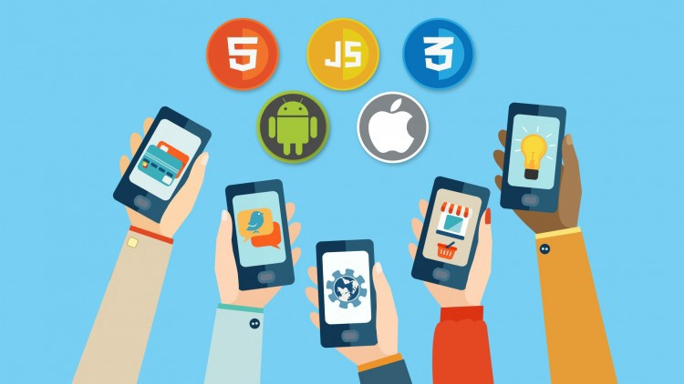

Fig 3.12 different OS using JavaScript.

**Chapter Four**

**Conclusion and Future Work**

**4.1 Conclusions**

We have introduced the smart Mobile Application for Improve Recycling which will have a great impact on the environment and pollution, the environmental culture, all kinds of a human and live creature.

The system has many benefits including:

* Improve environmental culture.
* Getting financial benefits.
* Safe the environment.

Some challenges we have in our project which is to consider collecting the garbage in a feasible way to cover all the financial needs. Using the car also is a big challenge; we solved it by using the garbage cars at times that are unused.

**4.2 Future Work**

We will use the collected data about customers in the future to expect what type and the amount of produce waste each week or month. Using AI and data mining we will expect these values.

We will also send the user message to get out the garbage before the car arrived so the car will not need to wait.

The database will be done in the 3rd normal form.

Some of the advantages that can be added are:

* The system will know how much each customer will produce and it will go collecting the garbage without making user even request because it already learned about it.
* It will be faster collection activities.
* Using AI and data mining will make it easy on the user to not even bother to request.
* The user will get money for consumption and making garbage, so just because you are alive and produce waste, you get money.

**References**

**[1] Management center of Zahrat Al-Finjan [phone call] Available at:**

**Mohammad Alsaadi (Technical Director of Zahray Al-Finjan) by Mohammad khuzayma (Financial Director Zahray Al-Finjan) [Accessed 18 March 2019 at 4:00 PM]**

**[2] Sayidy.net [online] Available at :**

[**https://www.sayidy.net/article/102136/%D8%B9%D9%84%D9%88%D9%85-%D9%88%D8%AA%D9%83%D9%86%D9%88%D9%84%D9%88%D8%AC%D9%8A%D8%A7/%D9%85%D8%A7-%D8%AD%D8%AC%D9%85-%D8%A7%D8%B9%D8%AA%D9%85%D8%A7%D8%AF-%D8%A7%D9%84%D8%B9%D8%B1%D8%A8-%D8%B9%D9%84%D9%89-%D8%A7%D9%84%D9%87%D9%88%D8%A7%D8%AA%D9%81-%D8%A7%D9%84%D8%B0%D9%83%D9%8A%D8%A9%D8%9F-%D8%A5%D9%84%D9%8A%D9%83%D9%85-%D8%A7%D9%84%D8%A3%D8%B1%D9%82%D8%A7%D9%85-%D8%A7%D9%84%D8%B5%D8%A7%D8%AF%D9%85%D8%A9**](https://www.sayidy.net/article/102136/%D8%B9%D9%84%D9%88%D9%85-%D9%88%D8%AA%D9%83%D9%86%D9%88%D9%84%D9%88%D8%AC%D9%8A%D8%A7/%D9%85%D8%A7-%D8%AD%D8%AC%D9%85-%D8%A7%D8%B9%D8%AA%D9%85%D8%A7%D8%AF-%D8%A7%D9%84%D8%B9%D8%B1%D8%A8-%D8%B9%D9%84%D9%89-%D8%A7%D9%84%D9%87%D9%88%D8%A7%D8%AA%D9%81-%D8%A7%D9%84%D8%B0%D9%83%D9%8A%D8%A9%D8%9F-%D8%A5%D9%84%D9%8A%D9%83%D9%85-%D8%A7%D9%84%D8%A3%D8%B1%D9%82%D8%A7%D9%85-%D8%A7%D9%84%D8%B5%D8%A7%D8%AF%D9%85%D8%A9) **[Accessed 20 March 2019 at 1:00 PM]**

**[3] Wafa.ps [online] Available at:**

[**http://info.wafa.ps/ar_page.aspx?id=9152**](http://info.wafa.ps/ar_page.aspx?id=9152) **[Accessed 22 March 2019 at 5:00 PM]**

**[4] Alaraby.co.uk [online] Available at:**

[**https://www.alaraby.co.uk/society/2015/9/4/%D9%85%D8%B4%D8%B1%D9%88%D8%B9-%D8%A5%D8%B9%D8%A7%D8%AF%D8%A9-%D8%AA%D8%AF%D9%88%D9%8A%D8%B1-%D8%A7%D9%84%D9%86%D9%81%D8%A7%D9%8A%D8%A7%D8%AA-%D8%A7%D9%84%D8%A5%D9%84%D9%83%D8%AA%D8%B1%D9%88%D9%86%D9%8A%D8%A9-%D9%81%D9%8A-%D8%A8%D9%88%D8%B1%D9%88%D9%86%D8%AF%D9%8A**](https://www.alaraby.co.uk/society/2015/9/4/%D9%85%D8%B4%D8%B1%D9%88%D8%B9-%D8%A5%D8%B9%D8%A7%D8%AF%D8%A9-%D8%AA%D8%AF%D9%88%D9%8A%D8%B1-%D8%A7%D9%84%D9%86%D9%81%D8%A7%D9%8A%D8%A7%D8%AA-%D8%A7%D9%84%D8%A5%D9%84%D9%83%D8%AA%D8%B1%D9%88%D9%86%D9%8A%D8%A9-%D9%81%D9%8A-%D8%A8%D9%88%D8%B1%D9%88%D9%86%D8%AF%D9%8A) **[Accessed 22 March 2019 at 6:00 PM]**

**[5] Okaz.com [online] Available at:**

[**https://www.okaz.com.sa/article/1063507?fbclid=IwAR1v2mvHEDaBNaeC38ze_sxKaTtJHDa98bgXkm2BRo3I9nXCKckpA-xm9e8**](https://www.okaz.com.sa/article/1063507?fbclid=IwAR1v2mvHEDaBNaeC38ze_sxKaTtJHDa98bgXkm2BRo3I9nXCKckpA-xm9e8) **[Accessed 22 March 2019 at 6:00 PM]**

**[6] Youtube.com [online] Available at:**

**https://www.youtube.com/watch?v=9yrP1CZN3Ds [Accessed 23 March 2019 at 1:00 PM]**

**[7] Youtube.com [online] Available at:**

[**https://www.youtube.com/watch?v=6jcp0Zarxmw&t=4s**](https://www.youtube.com/watch?v=6jcp0Zarxmw&t=4s) **[Accessed 23 March 2019 at 1:00 PM]**

**[8] Google.com [online, Research] Available at:**

[A SMART CLUSTERING BASED APPROACH TO DYNAMIC BANDWIDTH ALLOCATION IN WIRELESS NETWORKS]

[**https://www.google.com/url?sa=t&source=web&rct=j&url=http://www.aircconline.com/ijcnc/V8N1/8116cnc06.pdf&ved=2ahUKEwi49fXs2oziAhUJaVAKHfTIBE8QFjACegQIAxAB&usg=AOvVaw0JJxVs8gbc_uN3Yt1yaTwV&cshid=1557345283937**](https://www.google.com/url?sa=t&source=web&rct=j&url=http://www.aircconline.com/ijcnc/V8N1/8116cnc06.pdf&ved=2ahUKEwi49fXs2oziAhUJaVAKHfTIBE8QFjACegQIAxAB&usg=AOvVaw0JJxVs8gbc_uN3Yt1yaTwV&cshid=1557345283937) **[Accessed 8 may 2019 at 10:38 PM]**